**MADHAINSTITUTEOFENGINEERINGANDTECHNOLOGY**

# NMID:211221106006

SMARTPUBLICRESTROOM

INTERNETOFTHINGS-PHASE5-GROUP1

*SmartpublicrestroomscanleveragetheInternetofThings(IoT)toenhanceuserexperience,improvehygiene,andoptimizemaintenance.TheobjectivesofintegratingIoTintopublicrestroomsinclude:*

## Real-timemonitoring:

Implementsensorstomonitortheoccupancyofstallsandtheusageofutilities,suchaswaterandsoapdispensers,tooptimizecleaningschedulesandsupplymanagement.

## Maintenanceoptimization:

UtilizeIoTsensorstodetectissuessuchasleaks,overﬂows,orfaultyequipment,enablingproactivemaintenanceandreducingthedowntimeoffacilities.

## Resourcemanagement:

Trackresourceusage,includingwaterandelectricity,toidentifyareaswhereconservationcanbeimproved,leadingtoreducedoperationalcostsandasmallerenvironmentalfootprint.

## Enhancedhygiene:

IncorporateIoTdevicestoprovidetouchlessexperiences,includingautomaticﬂushing,touchlessfaucets,andsensor-operatedsoapdispensers,promotingacleanerandmorehygienicenvironment.

## Userfeedbackandsatisfaction:

IntegrateIoT-enabledfeedbackmechanisms,suchastouchscreenkiosksormobileapplications,togatheruserfeedback,enablingauthoritiestopromptlyaddressconcernsandimproveoverallusersatisfaction.

## Securityandsafety:

DeployIoT-enabledsurveillancecamerasandalertsystemstoensurethesafetyofusers,detervandalism,andpromptlyrespondtoemergencies,creatingasecureenvironmentforallvisitors.

## Accessibilityandinclusivity:

ImplementIoTtechnologiestocatertotheneedsofdifferently-abledindividuals,suchasautomateddoors,accessibleﬁxtures,andpersonalizedsettingsforenhancedinclusivity.

## Data-drivendecision-making:

CollectandanalysedatafromIoTdevicestoidentifyusagepatterns,peakhours,andpopularamenities,enablingauthoritiestomakeinformeddecisionsforinfrastructureupgradesandfacilitymanagement.

## Sustainabilityinitiatives:

IntegrateIoTsensorstomonitorenergyconsumption,wastemanagement,andoverallenvironmentalimpact,facilitating the implementation of sustainable practices and promoting eco-friendly initiatives within therestroomfacilities.

## Seamlessmaintenancerequests:

EnableuserstoreportissuesorrequestmaintenancethroughIoT-enabledinterfaces,ensuringthatproblemsareaddressedpromptlyandemcientlytomaintainahighstandardofcleanlinessandfunctionality.

## IOTDeviceSetup:

DeviceSelectionandPlacement:

ChooseIoTdevicessuchasoccupancysensors,waterﬂowsensors,automateddispensers,andsmartsurveillancecamerastailoredtotheneedsofthepublicrestroom.

Strategicallyplacethedevicestocapturerelevantdataandmonitorcriticalareas,includingstalls,

sinks,andentrypoints.

PowerandConnectivity:

EnsureastablepowersourcefortheIoTdevices,eitherthroughdirectelectricalconnectionsortheuseoflong-lastingbatteries.

Establishasecureandreliableinternetconnection,preferablyusingadedicatedWi-Finetwork,to

facilitatedatatransmissionandremotemonitoring.

ConﬁgurationandIntegration:

Followthemanufacturer'sinstructionstoconﬁgureeachIoTdeviceandintegrateitintothedesignatednetwork.

Setupthedevicestocommunicatewithacentralizedmanagementsystem,enablingreal-timedata

collectionandanalysis.

DataSecurityandPrivacy:

ImplementrobustsecurityprotocolstoprotectthedatacollectedbytheIoTdevicesfromunauthorizedaccessorbreaches.

Utilizeencryptiontechniquesandauthenticationmeasurestosafeguardsensitiveinformationand

maintainuserprivacy.

MonitoringandControlInterface:

Deployauser-friendlymonitoringandcontrolinterface,accessibleeitherthroughaweb-baseddashboardoradedicatedapplication,tooverseethefunctioningoftheIoTdevicesinrealtime.Enable remote control capabilities to manage settings, receive alerts, and perform necessaryadjustmentsasrequired.

## IOTPlatformdevelopment:

AutomationandControlFeatures:

Incorporateautomationcapabilitieswithintheplatformtoenableremotecontrolofrestroomfunctions,suchaswaterﬂow,airquality,andwastemanagement.

Integrateschedulingalgorithmstoautomateroutinetasksandoptimizeresourceutilizationbasedonpredeﬁnedparameters.

DataAnalyticsandReportingTools:

Implementdataanalyticstoolstoprocessandanalysethecollecteddata,generatingactionableinsightsforoptimizingrestroomoperationsandenhancinguserexperiences.

Developcustomizablereportingfeaturesthatprovidedetailedanalytics,performancemetrics,and

trendanalysisforinformeddecision-making.

# Codeimplementation:

importrandom

defget_occupancy_data():

returnrandom.choice([True,False])#Simulatingrandomdatafordemonstrationdefget_water_ﬂow_data():

eturn round(random.uniform(0.5, 2.5), 2)# Simulating random water ﬂow data for demonstrationdefcontrol_devices(occupancy,water_ﬂow):

ifoccupancy:

print("Restroomisoccupied.Activatingappropriatesystems.")else:

print("Restroomisunoccupied.Systemsonstandby.")defmain():

whileTrue:

occupancy_data=get_occupancy_data()water_ﬂow_data=get_water_ﬂow_data()

print(f"Occupancy:{occupancy_data},WaterFlow:{water_ﬂow_data}liters/minute")control_devices(occupancy_data,water_ﬂow_data)

time.sleep(5)#Simulatinga5-seconddelayfordemonstrationpurposes

ifname=="main":

main()

# Schematic:

SmartPublicRestroomMakingPublicRestroomSmartandHygienic

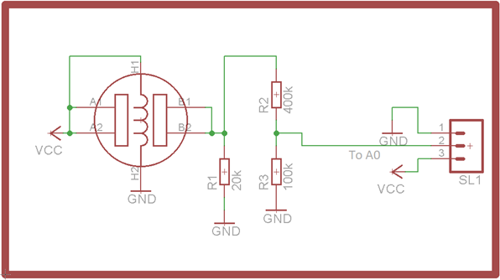

## Diagram:

Smartpublicrestroom

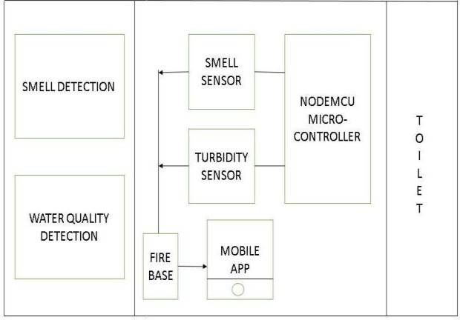

# AnexampleNodemcuesp8266:

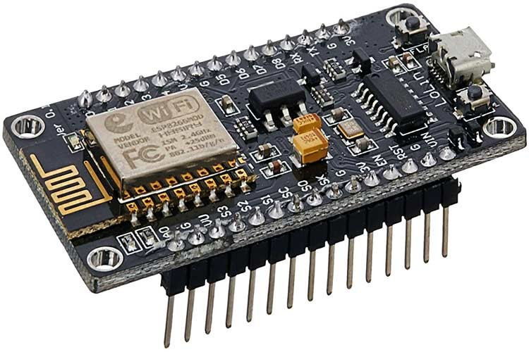

**PROJECTDETAILS**

IoT-enabledoccupancysensorscantrackthenumberofindividualsusingtherestroom,allowingforbettermanagement of cleaning schedules and resource allocation. This data helps restroom administratorsoptimizestamngandmaintenanceefforts.

IoTdevicesfacilitatetheautomationofvariousprocesses,suchasautomatedﬂushing,touchlessfaucets,and sensor-operated soapand sanitizerdispensers. Thesesystems promote ahygienic andtouchlessrestroomexperience,reducingthespreadofgermsandimprovingoverallcleanliness.

IoTsensorscanmonitorresourceusage,includingwaterandelectricity.Bycollectingdataonconsumptionpatterns, the restroom can implement measures to conserve resources, reduce waste, and promotesustainablepractices.

IoT devices can detect issues like leaks, malfunctions, or low supply levels in real-time. By promptlyidentifyingandaddressingtheseissues,maintenanceteamscanimproveemciency,reducedowntime,andensureaseamlessrestroomexperienceforusers.

BycollectingandanalysingdatafromIoTdevices,restroommanagerscangainvaluableinsightsintousagepatterns, peak hours, and maintenance requirements. This data-driven approach enables informeddecision-making,leadingtobetterresourceallocationandimprovedservicedelivery.

Smart restrooms can incorporate user feedback systems, such as touchscreens or mobile applications,allowingvisitorstoreportissues,providesuggestions,orratetheirexperience.Thisfeedbackmechanismenablesadministratorstoaddressconcernspromptlyandenhanceusersatisfaction.

IoT-enabled surveillance cameras and alert systems can ensure the security of restroom users and detervandalismorcriminalactivities.Thesesystemsprovideasafeandsecureenvironmentforvisitors,boostingtheirconﬁdenceandtrustinthefacility.

IoTtechnologycanfacilitatetheinclusionofaccessibilityfeaturesfordifferently-abledindividuals,suchasautomateddoors,adjustableﬁxtures,andpersonalizedsettings,ensuringthattherestroomisaccessibleanduser-friendlyforall.

|  |  |
| --- | --- |
| **TEAM MEMBERS:** | **211221106003** |
|  | **211221106004** |
|  | **211221106005** |
|  | **211221106006** |
|  | **211221106007** |
|  | **211221106008** |